Nurture Group Research FAQ
Why do we need nurture groups?
Many vulnerable children are underachieving because of social and emotional barriers caused by challenging circumstances in the early years– we now know that the early promise shown by the brightest poor students can be lost as they progress through school,1 that only one in three disadvantaged students achieve five good GCSEs passes,2 and that those with a low level of educational attainment are almost five times more likely to be in poverty now as those with a high level of education.3 To highlight how many children could potentially be underachieving due to social and emotional barriers, studies like that of Sutton Trust’s Baby Bonds paper, which found that 40 per cent of children are insecurely attached,4 have certainly helped us to understand the severity and scale of the problem. Currently, one in 10 children and young people aged five to 16 suffer from a diagnosable mental health disorder (around three children in every class),5 and the costs of long-term mental disorders over a lifetime are currently costing the UK an estimated £70 billion annually.6

So the earlier the intervention the better?
There is a wide consensus that the foundation years are a critical period for a truly preventative approach. For example, in Early Intervention: The Next Steps, Graham Allen made a compelling case for investing in policies and programmes that promote early intervention, particularly in the foundation years. Graham Allen argues that, “Building their essential social and emotional capabilities means children are less likely to adopt antisocial or violent behaviour throughout life. It means fewer disruptive toddlers, fewer unmanageable school children, fewer young people engaging in crime and antisocial behaviour. Early intervention can forestall the physical and mental health problems that commonly perpetuate a cycle of dysfunction”. However, nurture group provision is never too late. Children and young people have the same basic needs – to be loved, accepted and encouraged – whether they are four or 14. Secondary nurture groups support all these needs and minimise the chances of young people becoming non-attendees further through the school system.

What evidence do you have that nurture group provision works?
There are over 62 academic studies in the last two decades researching nurture group provision, including five non-randomised studies that have shown children and young people attending nurture groups are more likely to improve in social and emotional functioning than their peers that remain in the mainstream class.

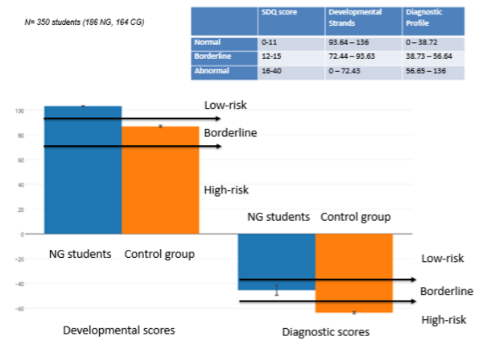
These studies are:
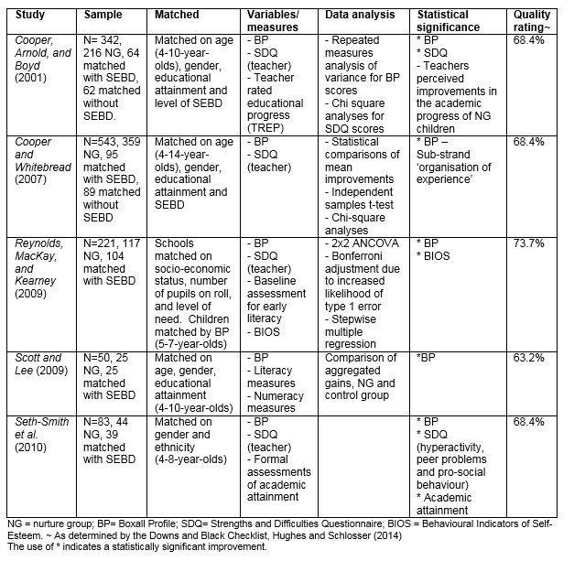
Why do nurture groups work?
Seth-Smith et al. (2010):
“The overall decrease in SEBD features in nurture group children may be due to improved social skills. The small group facilitates the development of interactive skills such as turn taking. The sustained emphasis on considerate behaviour facilitates positive social interactions between children that are mutually rewarding … Pro-social behaviour is known to predict peer acceptance (Dodge, 1983; Ladd et al., 1988). Children in nurture groups learn behaviour that renders them more rewarding and likable to both peers and adults. Underlying the development of social and friendship skills are a specific and evolving set of social and cognitive capacities, including empathy (Hay et al., 2004). Nurture groups place particular emphasis on promoting children’s ability to recognise and communicate about feeling states in themselves and their peers. Improvements in peer group relationships have a protective function if they generalise into children’s lives. Evidence suggests that these improvements are sustained in nurture group children; reintegration into the mainstream class has shown to be successful following time in nurture groups (Iszatt & Wasileska, 1997). Nurture group children’s interactions are also likely to be influenced by the teacher’s attitudes to their peers, many of whom would in a mainstream classroom be experienced as ‘disruptive.’ Evidence suggests that peers make use of their observations of teacher-child interactions to inform their own interactions with a particular child (Hughes et al., 2001; Meehan et al., 2003), therefore, changed teacher attitudes can impact on peer acceptance (Zionts et al., 2004).” (p. 30)

What are the most common social, emotional and behavioural difficulties in nurture groups?
The most common social, emotional and behavioural difficulties of children undergoing NG provision in a study of 100 nurture groups were the following:
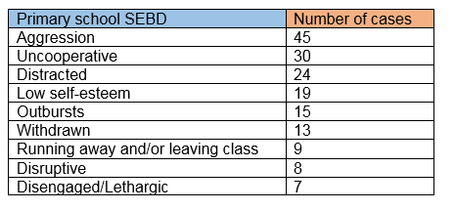
That list includes both internalising and externalising behaviour - does nurture group provision help with both?
Nurture groups benefit both internalising and externalising behaviour. In a pilot study of 100 nurture groups7the primary nurture pupils exhibiting unaggressive SEBD increased their performance on the Developmental Strand of the Boxall Profile more than those exhibiting aggressive SEBD, though both groups improved in general.
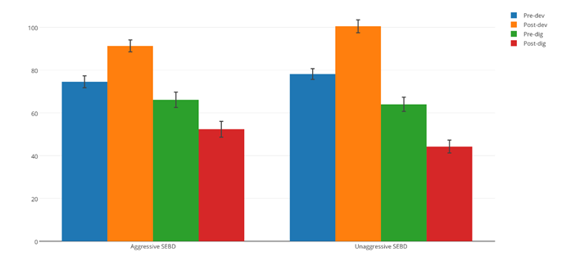
The primary nurture pupils increased their performance on the Developmental Strand of the Boxall Profile following the intervention as shown by the increase in scores (from blue to orange). In addition, the pupil’s performance on the Diagnostic Profile of the Boxall Profile was also enhanced following the intervention, as shown by the decrease in the scores (from green to red).

Who is the average nurture pupil?
In the pilot study he was a little boy in Key Stage One who lives with his single mother and at least one other sibling and has little to no contact with his father. He is highly likely to have experienced significant trauma at some point in his life, and his mother is likely to suffer from some kind of mental illness. His behaviour at school is most likely to be described as aggressive, uncooperative and distracted and he suffers from lack of self-worth. Though he is described as bright his volatile behaviour significantly hinders his academic progress. He is more than likely to have a strained relationship with his peers and have no friends at school. After NG provision he is likely to have at least one more friend at school, a better relationship with his parents/guardians, and be more likely to reach a state of attentive calm in the mainstream classroom which allows him to significantly improve his attainment, attendance and self-confidence.

Are nurture groups only for children and young adults with SEBD struggling academically?
No. Bright children achieving levels at or above age-appropriate targets made up half of the NG students in the 100 nurture group study. Both bright children and those that were below or significantly below average academically had similar gains in social and emotional functioning post-provision. These gains in emotional intelligence allowed students of all ages and academic levels – both in primary and secondary school – to adopt better ways of dealing with academic stress and have wider social networks concomitantly resulting in improved grades (as noted in their pen profiles).

Does nurture group provision address and remediate social, emotional and mental health problems?
Yes. Students with SEBD are significantly more likely to improve in social and emotional functioning by attending NG provision than remaining in their mainstream classroom. One study found that children’s SDQ scores in the abnormal or borderline category improved by 29% to normal levels are three terms of NG provision compared to only 10% in the control group.8

Are gains made in nurture groups maintained over time?
Yes, gains in social and emotional functioning are maintained over time by NG students.9

Does nurture group improve attendance?
Both Ofsted in their 2013 ‘Pupil Premium’ paper, and Estyn in their 2014 ‘Attendance in Secondary Schools’ paper, have recommended nurture groups to improve the attendance in both primary and secondary schools respectively.

What evidence-based components are used in nurture groups to address and remediate SEBD?
Nurture group provision uses evidence-based components which aim to address and remediate social, emotional and behavioural problems in children and adolescents.
These 12 components are:10
Building affective bonds
- Builds positive, trusting relationships with pupils/good rapport/familiarity
- (Affection, attention, caring physical contact, early basic experiences and the
- reassurance that the student is valued)
- Labelled praise
- Emotionally nurturing atmosphere
- Responsive to individual needs
Consensual goal setting
- Sets achievable targets from Boxall Profile assessment
- Reviewing/reinforcing target behaviour/skills
Modelling
- Role modelling of appropriate behaviour/social skills between two adults participating in constructive interaction
- Peer modelling
Coping template / Positive self-instruction / Cognitive restructuring
- Methods to generate alternative solutions/evaluate options
- Perspective taking
- Recognising triggers of anger
- Forecasting future setbacks
- Deliberate exposure to what triggers negative thoughts/reactions along with a coping template
- Distinguishing between helpful and unhelpful thoughts
- Graded hierarchy approach (breaking-down worrying situations into manageable steps)
- Identifying other people who use good coping models
Rewards
- Behavioural reward systems: marble jars, team targets, sticker charts
- Prizes/gifts/books (dependant on behaviour and achievable targets)
- Golden time
- Extra play time
- Time with favourite teacher/class pet
- Taking the class toy home
Role-play exercises / Social skills training
- Practicing/rehearsing skills
- Re-enacting hypothetical situations
Affective Education
- Understanding, identifying and labelling emotions
- Recognising physical and environmental cues of emotions
- Providing opportunities for pupils to verbalise their emotional experiences
In-session curriculum / Structured tasks
- Curriculum planning and assessment as a collaborative responsibility between the nurture group practitioner and the mainstream teacher
- Circle time
Homework
- Assigning and reviewing tasks to complete
- Setting up behaviour charts for implementation at home/practicing skills
Relaxation techniques
- Mindfulness
- Controlled breathing techniques
- Identifying a range of activities which students find enjoyable and relaxing
Parental involvement
- Staff provide ideas/equipment for home activities and support parents to develop appropriate interaction strategies and management for home
- Parent praise
- Open afternoons or evenings are often held termly and younger siblings are welcomed
- A few parents spend part of the day or the entire day in the nurture group
Limit setting
- Ignoring negative behaviour
- Traffic light system
- Time ‘in’

What gaps in the research literature currently exist?
Though there are more than 62 studies (and counting!) involving nurture group research, including 5 non-randomised studies, one randomised control trial, and two systematic reviews, there are still many areas to explore. Including:
- Longitudinal studies that test the effects of NG provision over longer periods of time;
- Studies incorporating NG provision in secondary school;
- RCT trials;
- Qualitiative studies of effective NGs with different mixes of children with externalising/internalising behaviours, ages and gender;
- Studies on effective practices to involve parents in NG provision, especially hard to reach parents.
More questions?
Join the discussion at the nurture group research forum by clicking here.
------
1 Social Mobility and Child Poverty Commission(2014)https://www.gov.uk/government/news/smcpc-research-on-attainment-of-disadvantaged-children
2 Adams, R. (2015) http://www.theguardian.com/education/2015/jan/29/gcse-gap-rich-poor-widens
3 Office for National Statistics (2014) Which childhood factors predict low educational attainment
http://www.ons.gov.uk/ons/rel/household-income/intergenerational-transmi...eu/2014/sty-causes-of-poverty-uk.html?format=print
4 Sutton Trust (2014) Baby Bonds. Available online: http://www.suttontrust.com/wp-content/uploads/2014/03/baby-bonds-final.pdf
5 Green, H., McGinnity, A., Meltzer, H., et al. (2005). Mental health of children and young people in Great Britain 2004. London: Palgrave.
6 OECD (2014) UK needs to tackle high cost of mental-ill health, says OECDhttp://www.oecd.org/health/uk-needs-to-tackle-high-cost-of-mental-ill-health.htm
7 Scott Loinaz (2014) http://www.nurturegroups.org/what-we-do/research-and-evidence/pilot-study-summary
8 Cooper, Arnold, R. and Boyd, E. (2001). The effectiveness of nurture groups: preliminary research findings. British Journal of Special Education, 28 (4), 160–166.
9 O’Connor, Tina and John Colwell (2002). The effectiveness and rationale of the ‘nurture group’ approach to helping children with emotional and behavioural difficulties remain within mainstream education. British Journal of Special Education, Volume 29, Issue 2, 96–100.
10 Scott Loinaz, E (2014) http://www.nurturegroups.org/what-we-do/research-and-evidence/evidence-based-ng-practice

Nurture Group Census
In July 2015, the Nurture Group Network conducted a UK-wide census of nurture group provision (please click here to view list of schools with nurture groups). The census identified 2114 schools with nurture groups: 1876 in primary schools and 238 in secondary schools.
Nurture group to school ratio
The census found that there is:
1 nurture group for every 14.3 schools in England (1707)
1 nurture group for every 8.3 schools in Scotland (321)
1 nurture group for every 11.8 schools in Wales (144)
1 nurture group for every 45.2 schools in Northern Ireland (35)

Controlled studies
Edurne Scott Loinaz, BA MA (Ed)
To date, five nonrandomised studies have researched the effectiveness of nurture group provision by comparing improvements in social and emotional functioning and academic progress for children with social, emotional and behavioural difficulties (SEBD) in nurture groups compared to students with SEBD that remained in their mainstream classroom. The studies which included 1239 students, 89 schools with nurture group provision and 50 without, show that students with SEBD are significantly more likely to improve in social and emotional functioning and academic achievement by attending NG provision for at least two terms rather than remaining in their mainstream classroom. This was true for both full-time and part-time nurture group models. All five studies show statistically significant improvements in Boxall Profile scores, and half of the studies show statistically significant improvements using the Similarities and Differences Questionnaire. Two of the three studies that analysed academic attainment for both case and control groups showed a statistically significant advantage in academic progress for students that attended a nurture group compared to those that remained in the mainstream classroom.
Main variables and measures of the five studies
Boxall Profile
As shown in Table 1, the nurture pupils significantly increased their performance on the Developmental Strand of the Boxall Profile compared to the control group following two terms of provision as shown by the increase in scores. An increase in developmental scores is correlated with more pro-social behaviours such as: giving purposeful attention; participating constructively; engaging with peers/responding constructively; being emotionally secure; accepting constraints; and being accommodating.
In addition, the NG students’ performance on the Diagnostic Profile of the Boxall Profile was also enhanced following the provision, as shown by the decrease in the scores. A decrease in diagnostic scores is correlated with less anti-social behaviours such as: self-limiting features (disengaged and self-negating); underdeveloped behaviour (craving attachment and showing inconsequential behaviour); unsupported development (having an insecure sense of self and showing negativism towards self and others, avoiding attachment).
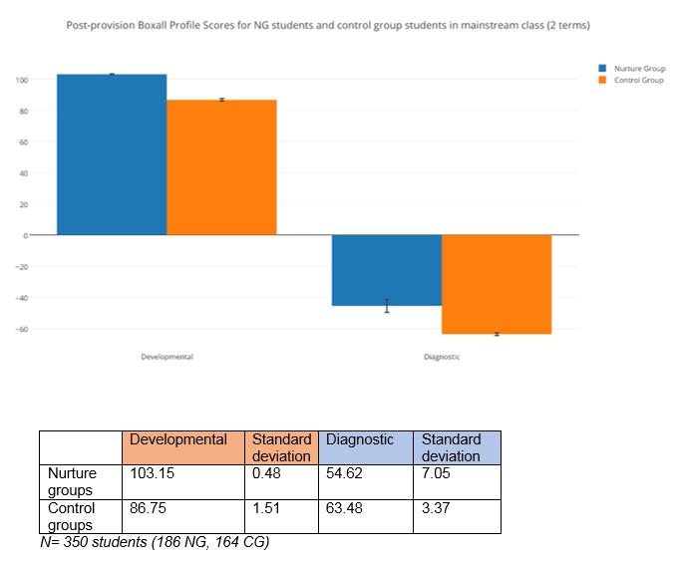
Strengths and Difficulties Questionnaire (teacher version)
As shown in Table 2, SDQ scores significantly improved for the nurture group students following two terms of NG provision compared to the control group as shown by the decrease in the scores. Cooper et al.’s (2001) study, for example, found that, “At entry, 92% of children in Nurture Groups are in the abnormal or borderline range on the SDQ, when they are observed in mainstream classrooms, compared with 84% of matched mainstream pupils with SEBD. By the third term, this has changed to 63% for Nurture Group pupils compared with 75% for pupils with SEBD. The mean differences between these scores is statistically significant (chi square, p=<.000).” (p. 163)
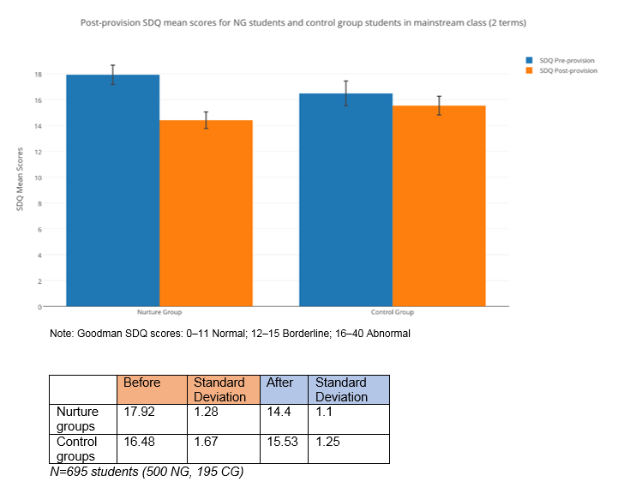
Academic Achievement
N=319 (163 NG, 156 CG)
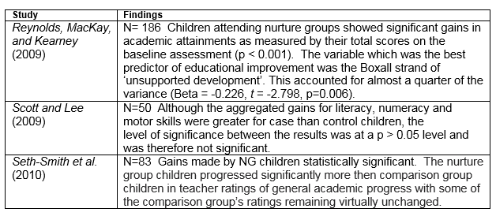
Why has there been such a significant improvement for students with SEBD in nurture group provision compared to students in mainstream classrooms?
Seth-Smith et al. (2010):
“The overall decrease in SEBD features in nurture group children may be due to improved social skills. The small group facilitates the development of interactive skills such as turn taking. The sustained emphasis on considerate behaviour facilitates positive social interactions between children that are mutually rewarding … Pro-social behaviour is known to predict peer acceptance (Dodge, 1983; Ladd et al., 1988). Children in nurture groups learn behaviour that renders them more rewarding and likable to both peers and adults. Underlying the development of social and friendship skills are a specific and evolving set of social and cognitive capacities, including empathy (Hay et al., 2004). Nurture groups place particular emphasis on promoting children’s ability to recognise and communicate about feeling states in themselves and their peers. Improvements in peer group relationships have a protective function if they generalise into children’s lives. Evidence suggests that these improvements are sustained in nurture group children; reintegration into the mainstream class has shown to be successful following time in nurture groups (Iszatt & Wasileska, 1997). Nurture group children’s interactions are also likely to be influenced by the teacher’s attitudes to their peers, many of whom would in a mainstream classroom be experienced as ‘disruptive.’ Evidence suggests that peers make use of their observations of teacher-child interactions to inform their own interactions with a particular child (Hughes et al., 2001; Meehan et al., 2003), therefore, changed teacher attitudes can impact on peer acceptance (Zionts et al., 2004).” (p. 30)
Cooper and Whitebread (2007):
“Both quantitative and qualitative data … point to the strong possibility that the presence of an effective NG adds value to the work that schools do with the wider population of children with SEBD. The qualitative data in particular indicate that mainstream staff develop more ‘nurturing’ approaches to pupils on the basis of their interactions with NG staff. These interactions are supported by the tangible benefits accrued by NG pupils from their placement in the NG, which are reflected in their mainstream performance as observed by mainstream staff.” (p. 187)
Cooper et al. (2001):
“Such a holistic approach has the potential to produce positive outcomes across a wide range of variables, including social, emotional, behavioural and educational functioning of children; parents’ attitudes towards their own children and the school; and the positive functioning of whole schools.” (p. 165)
Reynolds et al. (2009)
“Nurture groups are grounded in attachment theory (Bennathan & Boxall, 2000), and they represent a clearly-targeted intervention for addressing the emotional and behavioural issues of children with major difficulties in the development of secure attachments. Possible relationships between attachment and academic outcomes have been demonstrated in several studies of children and young people of various ages (see, for example, Jacobsen & Hofmann, 1997; Marcus & Sanders-Reio, 2001; Moss & St-Laurent, 2001).” (p. 20)
Scott and Lee (2009)
“The results [of the nurture group students] do indicate that they were able to maintain and surpass a level of progress comparable to that of their peers. This finding is important because it suggests that the fears of some of the class teachers that children might be disadvantaged by being placed in the group and therefore having less access to the formal curriculum, are misplaced. In fact overall the children seemed to have kept up with or surpassed the gains of their peers academically despite the loss of time, while ‘catching up’ in terms of their emotional and social development.” (p. 10)

Bibliography:
Cooper, P., Arnold, R. and Boyd, E. (2001), ‘The effectiveness of nurture groups: preliminary research findings.’ British Journal of Special Education, 28 (4), pp. 160–166.
Cooper, P. and Whitebread, D. (2007), ‘The Effectiveness of Nurture Groups: Evidence from a National Research Study.’ Emotional and Behavioural Difficulties, 12 (3), pp. 171-190.
Reynolds, S., Kearney, M. and MacKay, T. (2009), ‘Nurture Groups: a large – scale,
controlled study of effect on development and academic attainment.’ British Journal
of Special Education, 36 (4), pp. 204 – 212.
Scott, K. and Lee, A. (2009), ‘Beyond the ‘classic’ nurture group model: an evaluation of part-time and cross-age nurture groups in a Scottish local authority.’ Support for Learning, 24 (1) pp. 5-10
Seth-Smith, F., Netali L., Richard P., Fonagy, P. and Jaffey, D. (2010), ‘Do nurture groups improve the social, emotional and behavioural functioning of at risk children?’ Educational and Child Psychology, 27 (1), pp. 21-34
Please contact edurne@nurturegroups.org with any questions.

Systematic review of NG literature
Dr Hanna Bennett
The NGN conducted a systematic review of previous nurture group research collating data starting from the 1990s until March 2014. The review intended to highlight the key determinants that make Nurture Groups successful and to contribute to the continuous development of the NGN’s practice.
62 evaluative quantitative, qualitative and mixed studies were selected for the review - including PhDs, official reports, academic articles and books - the majority of which focused on analysing primary schools. They evidenced nurture groups’ ability to increase Social Emotional and Behavioural Development (SEBD) in children, improve the whole school ethos and positively impact on home-school relationships and also the wider societal context.
Nurture Groups’ Impact
Both younger and older pupils and those with internalising and acting out behaviour benefitted from Nurture Groups, which were demonstrated in increased SEBD scores measured through Boxall profiles, SDQ and qualitative interviews (Binnie and Allen 2008; Bishop and Swain 2000; Colwell and O'Connor 2002; Cooper and Tiknaz 2005; Cooper and Whitebread 2007; Reynolds et al 2009; Sanders 2007; Scott and Lee 2009; Seth-Smith et al 2010).
Nurture Groups also contributed to the whole-school environment through creating calmer class rooms and empowering teachers to meet the needs of children (Binnie and Allen 2008; Bishop and Swain 2000; Cooper 2001, 2004; Cooper and Tiknaz 2005; Cooper and Whitebread 2007; Doyle 2001, Doyle 2003; 2004; Lucas 1999; Reynolds et al 2009; Sanders 2007; Scott and Lee 2009).
Home-school relationships benefited, from pupils’ attitudes towards school to their parents feeling that they were given support and full recognition of the children’s needs (Binnie and Allen 2008; Sanders 2007; Seth-Smith et al 2010).
Overall, NG provision was found to be cost-effective in comparison to other educational interventions. They were estimated to reduce the cost in comparison to complex needs placements (£13,000), out-of-borough day schools (£17,000), out-of-borough independent schools (£40,000) and full-time LSA support (£14,000) to £1,883 per child in an established classic nurture group that has up to 30 children throughout the year (with no more than 12 children at any given time) (According to 2009 figures by Enfield’s Local Authority).
Key Determinants for Nurture Groups’ Effectiveness
While identifying a need for future research to clarify the key determinants that make Nurture Groups effective, the review was able to pin point some important conditions at child, Nurture Group, school and organisational levels.
It found that variations in children’s fluency in English and national curriculum attainment can explain variance in children’s progress (Cooper and Tiknaz 2005). Further research is nevertheless needed to understand to what extent child characteristics such as age, SEB challenges and gender matter, as no consensus on these factors has been reached.
Moreover, some Nurture Group characteristics, such as class environment, balanced group composition, good peer relations, and stability of staff and teacher partnerships were found to be important for successful Nurture Groups (Cooper and Tiknaz 2005; Whitehead 2012; Cooper et al 2001; Dowsell 2011; Garner 2010; Kourmoulaki 2013). Teacher experience and size of the class have not attracted much attention, although are hypothesized to have importance in Nurture Group effectiveness and require further research.
A whole-school policy was also found to be fundamental to the success of Nurture Groups and reintegration of pupils to the mainstream. Those schools where the whole-school community is committed to pupils’ needs were found to make the most out of Nurture Group provision (Cooper and Tiknaz 2005).
Organisational factors such as the time the group has been in existence, the proportion of the time spent in the group and the length of time spent in the group has attracted the most attention in past research. Findings showed that the groups that have been in existence for two or more years have been most efficient (Dowsell 2011; Papamichael 2012) and that both full and part-time groups have been equally beneficial in supporting children’s SEBD (Cooper and Whitebread 2007; Cooper and Tiknaz 2005; Garner 2010; Scott and Lee 2009). The two first terms were found to be the most important for SEBD improvements while cognitive progression seems to continue within the third and fourth terms (Cooper and Whitebread 2007).
Conclusions
- Gains in social and emotional functioning are maintained over time by NG students (O’Connor & Colwell, 2002);
- Children who attended a NG had a significant chance of improving their learning skills (Gerrard, 2005),including language and literacy skills (Hosie, 2013);
- NGs resulted in an improvement in pupils’ behaviour and social skills (Cooper & Tiknaz, 2005);
- Pupils with SEBD in mainstream classrooms improved in behavioural terms significantly better than pupils with and without SEBD attending schools that did not have NG provision (Cooper & Whitebread, 2007);
- NGs resulted in a positive change to SEBD in school, at home and an increased ethos at school (Binnie & Allen, 2008);
- NGs result in a positive attachment to school (Walker, 2010);
- The best results have been achieved when the nurture group has been in existence for at least for two years (Cooper and Whitebread 2007; Rautenbach 2010; Garner 2010)

Pilot study summary
Edurne Scott Loinaz, BA MA (Ed)
In March/April 2014, the Nurture Group Network conducted a pilot study of approximately 100 nurture groups; 139 children and young adults between the ages of 3- to 15-years old undergoing nurture group provision (Type 1, 2 or 3) were included in the study. Using the anonymised pen profiles written by teachers, teaching assistants and SENCOs undertaking the NGN three-day certificate course, the study made the following findings:
Student characteristics
- All children regardless of age significantly improved in their social and emotional functioning post-provision according to their Boxall Profile test scores (the significance judged on two-tailed, paired student’s t-tests). The Boxall Profile is a detailed psychometric assessment of social, emotional and behavioural functioning.
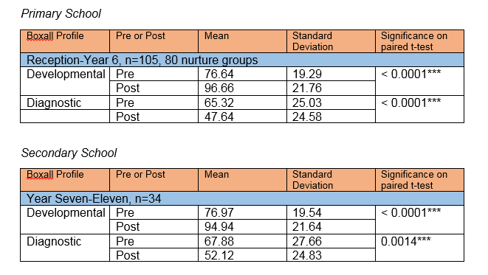
- The majority of the children in the primary study – 3 in every 5 – had experienced significant trauma in their lives, as well as the majority of secondary school students (85%). These external stressors included separation from family, exposure to family conflict, abuse, divorce, a new home or school, illness and hospitalization, death of a loved one, parental drug exposure, and maternal depression.
- 19% of primary school students in NGs had a diagnosed psychiatric disorder; this increased to 42% of secondary school students in NGs. The most common psychiatric disorder was ADHD.
NG provision
- The average Nurture Group in the primary study was a part-time model (5 mornings a week), established for less than a year and with 8 children.
- The average provision lasted 2-3 terms (KS1: 6 months; KS2: 7.5 months; KS3: 6.3 months; KS4: 7.1 months)
- All NG provisions had some positive effect (regardless of time established, setting, length of provision, full- or part-time model, and number of children attending NG), but the ideal NG provision for primary was still found to be a classic full-time nurture group run for three terms.
What are the most common SEBD in nurture groups?
Primary Schools
The most common social, emotional and behavioural difficulties of children undergoing NG provision in primary school were the following:
Other reported SEBD included attention-seeking behaviour, stealing, swearing/verbal abuse, being confrontational, being excitable/erratic, feigning illness, self-harm, saying inappropriate comments/shouting in class, throwing things, lying, being anxious to please/need for constant reassurance, bullying, immaturity, being controlling, issues with food, speech problems, inability to share, encopresis, and destroying their own and others’ work.
Table 1:
As shown in Table 1 and Table 2, the primary and secondary school nurture pupils exhibiting unaggressive SEBD significantly increased their performance on the Developmental Strand of the Boxall Profile following the intervention as shown by the increase in scores (from blue to orange). In addition, the pupil’s performance on the Diagnostic Profile of the Boxall Profile was also enhanced following the intervention, as shown by the decrease in the scores (from green to red).
Secondary Schools
The most common social, emotional and behavioural difficulties of children undergoing NG provision in secondary schools were the following:
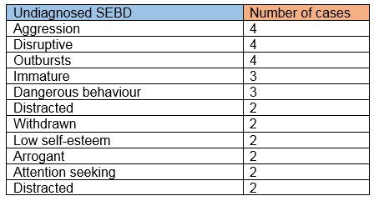
Other reported SEBD included swearing, leaving school, destroying work, anger issues, self-harm, moodiness, defiance and substance abuse.
Table 2:
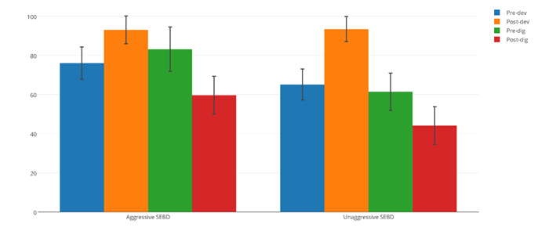
Who is the average nurture pupil?
In the pilot study he was a little boy in Key Stage One who lives with his single mother and at least one other sibling and has little to no contact with his father. He is highly likely to have experienced significant trauma at some point in his life, and his mother is likely to suffer from some kind of mental illness. His behaviour at school is most likely to be described as aggressive, uncooperative and distracted and he suffers from lack of self-esteem. Though he is described as bright his volatile behaviour significantly hinders his academic progress. He is more than likely to have a strained relationship with his peers and have no friends at school. After NG provision he is likely to have at least one more friend at school, a better relationship with his parents/guardians, and be more likely to reach a state of attentive calm in the mainstream classroom which allows him to significantly improve his attainment, attendance and self-confidence.
Are nurture groups only for children and young adults with SEBD struggling academically?
No. Bright children achieving levels at or above age-appropriate targets made up half of the NG students in the study. Regardless, both bright children and those that were below or significantly below average academically had similar gains in social and emotional functioning post-provision.
Table 3:
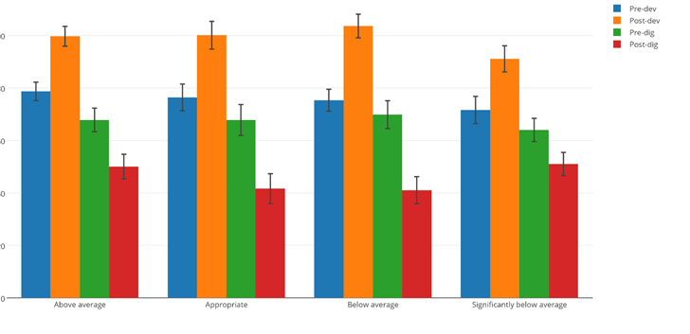
These gains in emotional intelligence allowed students of all ages and academic levels – both in primary and secondary school – to adopt better ways of dealing with academic stress and have wider social networks concomitantly resulting in improved grades (as noted in their pen profiles). This finding is also true of other social and emotional literacy programmes and psychosocial interventions which have found a link between gains in social and emotional functioning and greater academic performance (Eisenberg, Fabest et al, 2000; Guil, Mestre & Gil Olarte, 2004; Guil, Gil Olarte, Mestre & Núñez, 2005; Gil Olarte; Marquez et al, 2006); prosocial and other positive behaviours (Nellum, Williams 1997; Rubin, 1999; Johnson, 2002; Vorbach, 2002; Lopes et al., 2003; Denham et al., 2003; Lopes et al., 2004; Trinidad & Marquez et al., 2006); and finally, healthy attachments to school and community (Agostin And Bain, 1997; O'Neil, Welsh, Parke, Wang and Strand, 1997).

Evidence-based NG practice
Edurne Scott Loinaz, BA MA (Ed)
Nurture group provision uses evidence-based components which aim to address and remediate social, emotional and behavioural problems in children and adolescents. These 12 components are:
Building affective bonds
- Builds positive, trusting relationships with pupils/good rapport/familiarity (Affection, attention, caring physical contact, early basic experiences and the reassurance that the student is valued)
- Labelled praise
- Emotionally nurturing atmosphere
- Responsive to individual needs
Consensual goal setting
- Sets achievable targets from Boxall Profile assessment
- Reviewing/reinforcing target behaviour/skills
Modelling
- Role modelling of appropriate behaviour/social skills between two adults participating in constructive interaction
- Peer modelling
Coping template / Positive self-instruction / Cognitive restructuring
- Methods to generate alternative solutions/evaluate options
- Perspective taking
- Recognising triggers of anger
- Forecasting future setbacks
- Deliberate exposure to what triggers negative thoughts/reactions along with a coping template
- Distinguishing between helpful and unhelpful thoughts
- Graded hierarchy approach (breaking-down worrying situations into manageable steps)
- Identifying other people who use good coping models
Rewards
- Behavioural reward systems: marble jars, team targets, sticker charts
- Prizes/gifts/books (dependant on behaviour and achievable targets)
- Golden time
- Extra play time
- Time with favourite teacher/class pet
- Taking the class toy home
Role-play exercises / Social skills training
- Practicing/rehearsing skills
- Re-enacting hypothetical situations
Affective Education
- Understanding, identifying and labelling emotions
- Recognising physical and environmental cues of emotions
- Providing opportunities for pupils to verbalise their emotional experiences
In-session curriculum / Structured tasks
- Curriculum planning and assessment as a collaborative responsibility between the nurture group practitioner and the mainstream teacher
- Circle time
Homework
- Assigning and reviewing tasks to complete
- Setting up behaviour charts for implementation at home/practicing skills
Relaxation techniques
- Mindfulness
- Controlled breathing techniques
- Identifying a range of activities which students find enjoyable and relaxing
Parental involvement
- Staff provide ideas/equipment for home activities and support parents to develop appropriate interaction strategies and management for home
- Parent praise
- Open afternoons or evenings are often held termly and younger siblings are welcomed
- A few parents spend part of the day or the entire day in the nurture group
Limit setting
- Ignoring negative behaviour
- Traffic light system
- Time ‘in’

Nurture Groups in Secondary Schools
Secondary school nurture group case study: changes in social and emotional aptitude over six terms and their effect on academic achievement and attendance
Edurne Scott Loinaz, BA, MA (Ed)
Summary:
Using the concurrent validity scores of the Boxall Profile and the Strengths and Difficulties Questionnaire, this study used 20 secondary school students’ Boxall Profile scores taken over six terms to analyse changes in social and emotional aptitudes and their effect on academic achievement and attendance. The study found that the majority of the cohort shifted from high-risk scores on the SDQ (correlated to a 25-60% chance of being diagnosed with a psychiatric disorder), to low-risk scores (correlated to a 1-4% chance). (YouthinMind 2009) Students in the low-risk category were also more likely to get 5 GCSEs A*-C, and improve their attendance in Key Stage 4. The greatest gains in both the developmental strands (the positive ‘building blocks’ to wellbeing and learning) and the diagnostic profile (the negative ‘barriers’ to wellbeing and learning) were witnessed in the first two terms of the provision, although mental health improvements were maintained (and improved) in the following four terms.
Cohort characteristics
The cohort of 20 students for this study attended a part-time nurture group in 2009 and 2010 in a Norfolk secondary school with over 1000 students. The average nurture group provision was three periods a day, five days a week, for one to two terms (70% of the students’ time in Year 7). This decreased to an average of four periods a week the following year (10% of Year 8). The most common learning disabilities, as well as social, emotional and behavioural difficulties in the cohort included dyslexia, anxiety, ADHD, BESD and dyscalculia.
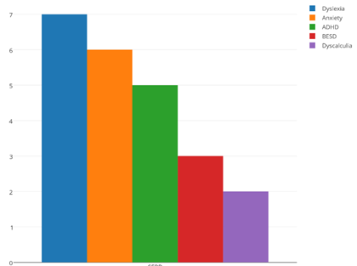
Other diagnosis included OCD, low self-esteem, Asperger’s, Meares Irlen, Dyspraxia, SLCN, Global Developmental Delay, poor attention, poor short-term memory and poor social skills.
The cohort was split 50/50 between students receiving the Pupil Premium, with 8 out of the 20 students receiving Free School Meals; and the ratio of male to female students was 17:3.
Numerous other projects the NG students participated in included family learning days, performing arts and intergenerational projects (visiting residential and nursing homes).
Concurrent validity of the BP and SDQ
In 2011, Couture, Cooper and Royer conducted a study of the concurrent validity between the Boxall Profile and the Strengths and Difficulties Questionnaire with 202 students aged 3-14 years. They concluded that the BP and the SDQ measure comparable features in children and adolescents, and that “the statistical evidence suggests that the BP is suitable for use in a research context.” (p. 28) The concurrent validity of both tests is summarised in Table 1.
Table 1. Concurrent validity of the BP and SDQ in Couture et al. (2011)
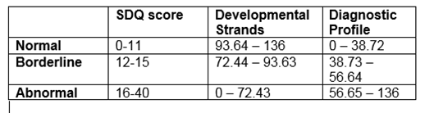
Using the Boxall Profile scores over six terms (one BP a term, six in all), the concurrent rating in the SDQ could be determined, along with how long it took to have students change from a high-risk case, where they would have a 25-60% of being diagnosed with a psychiatric disorder, to a low-risk case, where the chances of diagnosis fall to 1-4%.

Developmental
Graph 2. Change in Developmental Boxall Scores in six academic terms. N=20
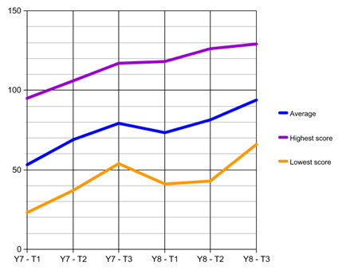
Graph 3. Change in Developmental Boxall Scores in six academic terms. N=20
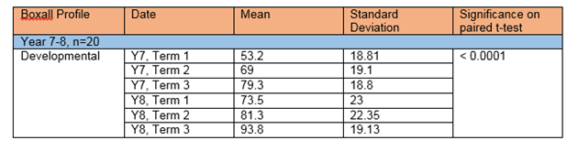
There was a statistically significant improvement in the developmental strands of the Boxall Profile between the first term of Year 7, and the last term of Year 8. The greatest gains were still made in the first two terms, which is similar to research in primary school nurture groups which found strong evidence that most SEBD improvements take place in the first two terms (Cooper 2004; Scott and Lee 2009; Cooper and Whitebread 2007; Cooper and Whitebread 2007; Sanders 2007; Broadhead et al 2011). There was, however, another positive spike in developmental scores between the second and third terms of Year 8, showing how mental health improvements can be maintained and even improve over time. The only fall in scores occurred during the summer holidays between the two academic years were scores showed a deterioration in mental wellbeing both developmentally and diagnostically.
The gains in developmental scores correlate with the concurrent SDQ scores (as detailed in Table 1), which showed that by the third term of Year 7 the majority of the students were no longer in the high-risk category. By the end of study, the majority of the students were considered low-risk and had made a full recovery (lowered their risk of psychiatric diagnosis from 25-60% to 1-4%). (YouthinMind 2009)
Graph 4. Change in SDQ Scores in six academic terms. N=20
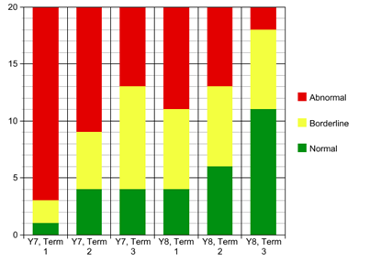

Table 5. Change in SDQ Scores in six academic terms. N=20
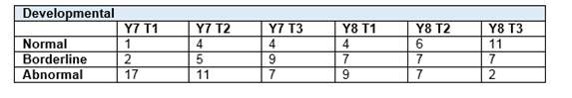
Diagnostic
Graph 6. Change in Diagnostic Boxall Scores in six academic terms. N=20
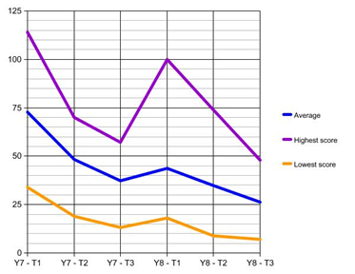
Table 7. Change in Diagnostic Boxall Scores in six academic terms. N=20
There was a statistically significant improvement in the diagnostic strands of the Boxall Profile between the first term of Year 7, and the last term of Year 8. Like the developmental strands, the greatest gains were still made in the first two terms, and improvement continued onto the next academic year. Where the study differs from past nurture group research is that the diagnostic rather than the developmental strands showed the most improvement; this is different to past research which found that the developmental strands showed the most consistent and easy improvement (Sanders 2007 and O’Connor and Colwell 2002; Rauthenbach 2010, Cooke et al 2008; Broadhead et al 2011; Cooke et al 2008; Farrell & Emanuel 2009). A possible reason for this is that the diagnostic profile on the BP is more similar to the SDQ, the SDQ examining 25 attributes (most of them negative), the diagnostic profile examining 34 negative attributes; the developmental strand on the other hand takes into account positive attributes and the building blocks of wellbeing and learning. The concurrent scores of the BP used in Table 1 showed that by the end of the study no children were scoring abnormally on the diagnostic profile.
Graph 8. Change in SDQ Scores in six academic terms. N=20
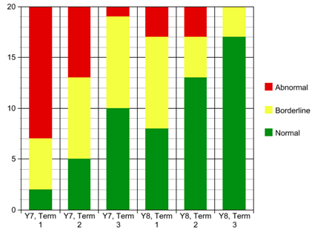

Table 9. Change in SDQ Scores in six academic terms. N=20
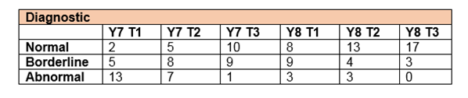
Academic Achievement
The study found a direct correlation between a low-risk score on the SDQ (both developmentally and diagnostically) and high academic achievement, as well as high-risk scores with low academic achievement. All of the students who were able to gain at least 5 GCSEs with scores from A* - C had all moved from an abnormal category to a normal category in the six terms. The two children who were still scoring abnormally in the developmental strand by the third term of Year 8 had the poorest GCSE results of the cohort; all students in the cohort, however, attempted at least two GCSEs (English and Maths). Currently 56.5% of pupils in state secondary schools are reaching the government benchmark of 5 GCSEs, including English and maths, at grade C or above. (Department of Education, 2014)
Table 10. SDQ rating and average GCSEs. N=20.
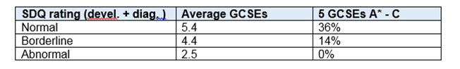
Attendance
Students that were considered low-risk at the end of the study were more likely to improve their attendance, whereas students in the high-risk category were more likely to have poorer attendance.
Table 11. SDQ rating and changes in attendance between Key Stage 2 and Key Stage 4. N=16.
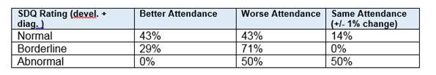
Conclusion
The study found that the majority of the cohort shifted from high-risk scores (correlated to a 25-60% chance of being diagnosed with a psychiatric disorder), to low-risk (correlated to a 1-4% chance) using their Boxall Profile results. Students in the low-risk category were also more likely to get 5 GCSEs A*-C, and improve their attendance. The greatest gains in both the developmental strands (the positive ‘building blocks’ to wellbeing and learning) and the diagnostic profile (the negative ‘barriers’ to wellbeing and learning) were witnessed in the first two terms of the provision, although mental health improvements were maintained (and improved) throughout the next four terms.
Works cited:
Broadhead et al (2011). Utilising the Boxall Profile within the Scallywags service for children with emotional and behavioural difficulties. British Journal of Special Education. Volume 38, Issue 1, pages 19–27.
Cooke, C. Yeomans, J.; Parkes, J. (2008). The Oasis: Nurture Group Provision for Key Stage 3 Pupils, Emotional and Behavioural Difficulties, volume13, n4, 291-303.
Cooper, P. and Whitebread, D. (2007). The Effectiveness of Nurture Groups: Evidence from a National Research Study. Emotional and Behavioural Difficulties, volume 12, n3 p171-190.
Cooper, Paul (2004). Learning from nurture groups. Education 3-13, 32(3).
Couture, C. Cooper, C. Royer, E. “A Study of the Concurrent Validity between the Boxall Profile and the Strengths and Difficulties Questionnaire.” The International Journal of Emotional Education, Vol. 3, No. 1, pp. 20- pp.29.
Farrell, P T., J Emanuel, Howes, A J. (2009) "Can nurture groups facilitate inclusive practices?." In Making special education inclusive, ed. Ainscow, M. Farrell, P, David Fulton, 2002.
O’Connor, Tina and John Colwell (2002). The effectiveness and rationale of the ‘nurture group’ approach to helping children with emotional and behavioural difficulties remain within mainstream education. British Journal of Special Education, Volume 29, Issue 2, 96–100.
Rautenbach, Roosje A. (2010). From nurture group to nurturing community: Exploring processes and evaluating outcomes when nurturing principles are consistent between nurture group, home and school (Unpublished PhD thesis). University of Exeter, United Kingdom.
Sanders, Tracy (2007). Helping Children Thrive at School: The Effectiveness of Nurture Groups. Educational Psychology in Practice, Volume. 23, Issue 1, 45-61.
Scott, K. and Lee, A. (2009), ‘Beyond the ‘classic’ nurture group model: an evaluation of part-time and cross-age nurture groups in a Scottish local authority.’ Support for Learning, 24 (1) pp. 5-10
YouthinMind (2009) http://www.sdqinfo.com/c5.html [Accessed 10 December 2014]

Nurture research links
- Volume one of a thesis submitted to The University of Birmingham toward the degree of Doctorate in Applied Educational and Child Psychology: "Evidence based practice in nurture groups: using a realistic evaluation framework to explore factors affecting practice and suggest furture training directions." by Oonagh M Davies
- An evaluation report from Glasgow City Council on the results achieved through nurture groups, along with a response from Sue Reynolds, Tommy MacKay and Maura Kearney.
- A document produced for The Welsh Assembly. Nurture Groups: A handbook for schools
- "Early Intervention in behaviour: The fast track programme as a pilot study" by Engelina Davids, West Lothian Council Psychological Service

The EEF Toolkit and Nurture Groups
The Education Endowment Foundation's Toolkit, a summary of educational research which provides guidance for teachers and schools on how to use their resources to improve the attainment of disadvantaged pupils, has an extensive evidence base to prove the efficacy of 14 out of 34 components.

Nurture groups use 10 out of these 14 effective evidence-base components as part of their provision:

PRIMARY AND SECONDARY NURTURE GROUPS:
- Meta-cognition and self-regulation: High impact for low cost, based on extensive evidence.
"Meta-cognition (sometimes known as ‘learning to learn’) and self-regulation approaches aim to help learners think about their own learning more explicitly. This is usually by teaching pupils specific strategies to set goals, and monitor and evaluate their own academic development. Self-regulation means managing one’s own motivation towards learning. The intention is often to give pupils a repertoire of strategies to choose from during learning activities ... Meta-cognition and self-regulation approaches have consistently high levels of impact with pupils making an average of eight months’ additional progress. The evidence indicates that teaching these strategies can be particularly effective for low achieving and older pupils. These strategies are usually more effective when taught in collaborative groups so learners can support each other and make their thinking explicit through discussion."
- Behaviour interventions: Moderate impact for moderate cost, based on extensive evidence.
"Evidence suggests that behaviour interventions can produce large improvements in academic performance along with a decrease in problematic behaviours, though there is relatively wide variation between alternative programmes. Effect sizes are larger for targeted interventions matched to specific students with particular needs or behavioural issues, than for universal interventions or whole school strategies ... The majority of studies report higher impact with older pupils. Different treatment approaches, such as behavioural, cognitive and social skills for aggressive and disruptive behaviour, seem to be equally effective. Parental and community involvement programmes are often associated with reported improvements in school ethos or discipline so are worth considering as alternatives to direct behaviour interventions."
- Social and emotional learning: Moderate impact for very low cost, based on extensive evidence.
On average, SEL interventions have an identifiable and significant impact on attitudes to learning, social relationships in school, and attainment itself (on average around three to four months additional progress). Improvements seem more likely when approaches are embedded into routine educational practices, and supported by professional development and training for staff. In addition, the implementation of the programme and the degree to which teachers were committed to the approach appeared to be important. SEL programmes appear to benefit disadvantaged or low-attaining pupils more than other pupils, though all pupils benefit on average. Approaches have been found to be effective from nursery to secondary school.
- Collaborative learning: Moderate impact for very low cost, based on extensive evidence.
Collaborative or cooperative learning can be defined as learning tasks or activities where students work together in a group small enough for everyone to participate on a collective task that has been clearly assigned. This can be either a joint task where group members do different aspects of the task but contribute to a common overall outcome, or a shared task where group members work together throughout the activity.
- Oral language interventions: "Moderate impact for low cost, based on extensive evidence.
Oral language interventions emphasise the importance of spoken language and verbal interaction in the classroom. They are based on the idea that comprehension and reading skills benefit from explicit discussion of either the content or processes of learning, or both. Oral language approaches include targeted reading aloud and discussing books with young children, explicitly extending pupils’ spoken vocabulary, and the use of structured questioning to develop reading comprehension. Overall, studies of oral language interventions consistently show positive benefits on learning, including oral language skills and reading comprehension. On average, pupils who participate in oral language interventions make approximately five months additional progress over the course of a year.
- Reading comprehension strategies: Moderate impact for low cost, based on extensive evidence.
Reading comprehension approaches to improving reading focus on learners’ understanding of the text. On average, reading comprehension approaches improve learning by an additional five months’ progress over the course of a school year. These approaches appear to be particularly effective for older readers (aged 8 or above) who are not making expected progress.
- Small group tuition: Moderate impact for moderate cost, based on limited evidence.
Here, small group tuition is defined as one teacher or professional educator working with two, three, four or five pupils. This arrangement enables the teacher to focus exclusively on a small number of learners, usually on their own in a separate classroom or working area. Intensive tuition in small groups is often provided to support lower attaining learners or those who are falling behind, but it can also be used as a more general strategy to ensure effective progress, or to teach challenging topics or skills. Research indicates that pupils taught in small groups make an average of four additional months’ progress when compared with larger groups or whole class teaching.
- One to one tuition: Moderate impact for high cost, based on extensive evidence.
One to one tuition is where an individual pupil is removed from their class and given intensive tuition. Short, regular sessions (about 30 minutes, 3-5 times a week) over a set period of time (6-12 weeks) appear to result in optimum impact. Evidence also suggests tuition should be additional to, but explicitly linked with, normal teaching, and that teachers should monitor progress to ensure the tutoring is beneficial. Studies comparing one to one to small group tuition show mixed results. In some cases one to one tuition has led to greater improvement, while in others tuition in groups of two or three has been as or more effective as one to one.
NURSERY AND PRIMARY NURTURE GROUPS:
- Early years intervention: High impact for very high costs, based on extensive evidence.
Overall, the evidence suggests that early years and pre-school intervention is beneficial with above average levels of impact (a typical impact of six additional months' progress). There is some international evidence that these programmes need to be for a whole day (rather than a half day which on average has less impact, though it should be noted the UK’s Effective Provision of Pre-School Education (EPPE) study did not find a difference) and of longer duration (up to a year or more) rather than for shorter periods of time ... In most studies, the impact on attainment tends to wear off over time, though impact on attitudes to school tends to be more durable. There is no established amount of time where the fade takes place, rather there is a pattern of decline over time. Early years and pre-school interventions are therefore not sufficient to close the gap in attainment for disadvantaged children.
- Phonics: Moderate impact for very low cost, based on extensive evidence.
Phonics is an approach to teaching reading, and some aspects of writing, by developing learners’ phonemic awareness. Phonics approaches have been consistently found to be effective in supporting younger readers to master the basics of reading, with an average impact of an additional four months’ progress. Research suggests that phonics is beneficial for younger learners (4-7 year olds) as they begin to read.
​The effective evidence-base components nurture groups did not have were: digital technology, peer tutoring, repeating a year and summer school. Click here to see The Education Endowment Foundation's Toolkit in full.

Inspection reports
We are exceptionally proud of the comments made by Ofsted, Estyn and HMIE inspectors on nurturing and nurture groups.
School inspectors always remark on the massive changes that attendance at a nurture group can have on a child's behaviour, social skills and emotional wellbeing, and truly help to build the case for the broader rolling out of nurture across the UK.

Estyn Reports
Tackling Disadvantage and Child Poverty in Schools (January 2010) (paragraph 45) talks about how nurture groups have been used to raise aspirations for those students from the most deprived and vulnerable backgrounds.
Evaluation of the implementation by schools and local education authorities of guidance on exclusions describes how nurture groups have been used to reduce the number of permanent exclusions from schools.
Estyn Inspection Report of Pembrokeshire Local Authority's Education Services (paragraphs 54 and 120) discuss the beneficial impact of nurture groups across the whole local authority.

HMIE Reports
Developing successful learners in nurturing schools: the impact of nurture groups in primary schools explores the impact of primary nurture groups in Scotland.
Out of site, out of mind? investigates work being done in local authority bases and special schools, and highlights nurture group as an example of best practice.
Ready for Life contains a case study of the work being done in nurture groups to improve students' emotional resilience and social skills (p.16)

Ofsted Reports
The exclusion from school of children aged four to seven discusses how nurture groups can reduce the number of permanent and temporary exclusions in very young children.
Managing Challenging Behaviour contains a case study of how nurture was effectively used by one local authority to engage a young person in study and voluntary work (p.16)

